Performance testing and hypher parameter tunning

Hypher parameter are parameters that can be fine-tuned and adjusted. This increases the accuracy score of a machine learning model. Machine algorithms such as Random forest, K-Nearest Neighbor an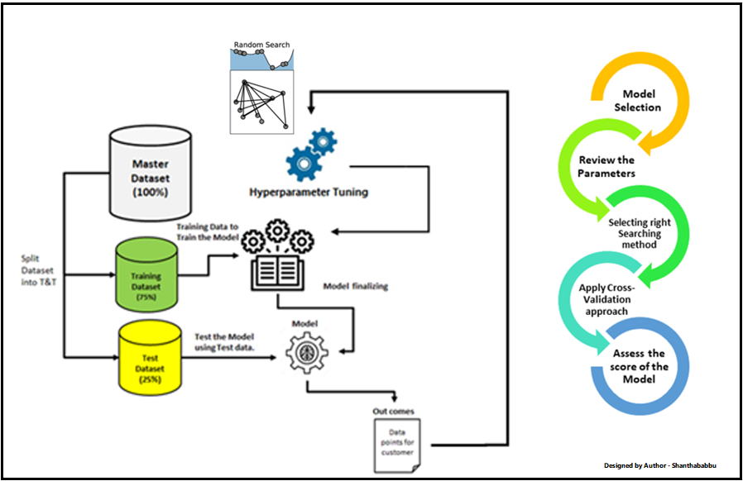d Decison trees have parameters that can be fine-tuned to achieve an optimized model

What are Hyperparameters? How to Differ from a Model Parameter?

As we know that there are parameters that are internally learned from the given dataset and derived from the dataset, they are represented in making predictions, classification and etc., These are so-called Model Parameters, and they are varying with respect to the nature of the data we couldn’t control this since it depends on the data. Like ‘m‘ and ‘C‘ in linear equation, which is the value of coefficients learned from the given dataset.

Some set of parameters that are used to control the behaviour of the model/algorithm and adjustable in order to obtain an improvised model with optimal performance is so-called Hyperparameters.

The best model algorithm(s) will sparkle if your best choice of Hyper-parameters

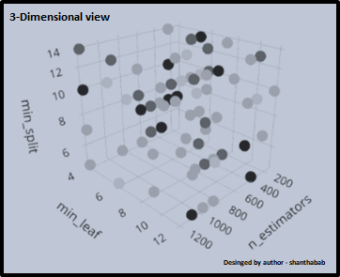

ML Life Cycle

If you ask me what is Hyperparameters in simple words, the one-word answer is Configuration.

Without thinking too much, I can say quick Hyperparameter is “Train-Test Split Ratio (80-20)” in our simple linear regression model. 